**MAD MOCK PRACTICAL EXAM**

**Code:**

1. Main.dart

import 'package:flutter/material.dart';

import 'display_page.dart';

void main() {

runApp(const MyApp());

}

class MyApp extends StatelessWidget {

const MyApp({super.key});

@override

Widget build(BuildContext context) {

return MaterialApp(

title: 'Book Store',

debugShowCheckedModeBanner: false,

home: const DisplayPage(),

);

}

}

1. Display Page:

import 'package:flutter/material.dart';

import 'menu_page.dart';

class DisplayPage extends StatelessWidget {

const DisplayPage({super.key});

@override

Widget build(BuildContext context) {

return Scaffold(

appBar: AppBar(

title: const Text('Book Store'),

backgroundColor: Colors.*blueAccent*,

),

body: SizedBox.expand(

child: Image.asset(

'assets/bookstore2.jpg',

fit: BoxFit.cover,

),

),

floatingActionButton: SizedBox(

width: 90,

height: 90,

child: FloatingActionButton(

onPressed: () {

Navigator.*push*(

context,

MaterialPageRoute(builder: (context) => const MenuPage()),

);

},

backgroundColor: Colors.*deepPurple*,

elevation: 8,

shape: RoundedRectangleBorder(

borderRadius: BorderRadius.circular(12),

),

child: const Icon(

Icons.*menu_book*,

color: Colors.*white*,

size: 48,

),

),

),

);

}

}

1. Menu page

import 'package:flutter/material.dart';

class MenuPage extends StatelessWidget {

const MenuPage({super.key});

final List<Map<String, String>> books = const [

{'image': 'assets/book1.jpg', 'name': 'Doctors by Erich Segal', 'price': 'Rs. 300'},

{'image': 'assets/book2.jpg', 'name': 'Wuthering Heights', 'price': 'Rs. 350'},

{'image': 'assets/book3.jpg', 'name': 'It Ends With Us', 'price': 'Rs. 400'},

{'image': 'assets/book4.jpg', 'name': 'Ugly Love', 'price': 'Rs. 450'},

{'image': 'assets/book5.jpg', 'name': 'A Farewell to Arms', 'price': 'Rs. 200'},

{'image': 'assets/book6.jpg', 'name': 'The Sun Also Rises', 'price': 'Rs. 320'},

{'image': 'assets/book7.jpg', 'name': 'Harry Potter: The Cursed Child', 'price': 'Rs. 500'},

];

@override

Widget build(BuildContext context) {

return Scaffold(

backgroundColor: Colors.*blueGrey*[50],

appBar: AppBar(

title: const Text('Available Books'),

backgroundColor: Colors.*blueAccent*,

),

body: ListView.builder(

itemCount: books.length,

itemBuilder: (context, index) {

return Card(

margin: const EdgeInsets.symmetric(horizontal: 16, vertical: 8),

elevation: 6,

shape: RoundedRectangleBorder(borderRadius: BorderRadius.circular(16)),

child: Padding(

padding: const EdgeInsets.all(14),

child: Column(

children: [

Row(

children: [

ClipRRect(

borderRadius: BorderRadius.circular(12),

child: Image.asset(

books[index]['image']!,

width: 90,

height: 90,

fit: BoxFit.cover,

),

),

const SizedBox(width: 16),

Expanded(

child: Column(

crossAxisAlignment: CrossAxisAlignment.start,

children: [

Text(

books[index]['name']!,

style: const TextStyle(

fontSize: 18,

fontWeight: FontWeight.*bold*,

),

),

const SizedBox(height: 6),

Text(

books[index]['price']!,

style: const TextStyle(

fontSize: 16,

color: Colors.*black87*,

),

),

],

),

),

],

),

const SizedBox(height: 12),

Row(

mainAxisAlignment: MainAxisAlignment.end,

children: [

TextButton(

onPressed: () {

ScaffoldMessenger.*of*(context).showSnackBar(

SnackBar(content: Text('Details of ${books[index]['name']}')),

);

},

child: const Text('Details'),

),

const SizedBox(width: 8),

ElevatedButton(

onPressed: () {

ScaffoldMessenger.*of*(context).showSnackBar(

SnackBar(

content: Text('Buying ${books[index]['name']}...'),

duration: const Duration(seconds: 2),

),

);

},

style: ElevatedButton.*styleFrom*(

backgroundColor: Colors.*deepOrange*, // 🔶 New button color

padding: const EdgeInsets.symmetric(horizontal: 20, vertical: 12),

shape: RoundedRectangleBorder(

borderRadius: BorderRadius.circular(10),

),

),

child: const Text(

'Buy Now',

style: TextStyle(color: Colors.*white*), // 🔠 New text color

),

),

],

),

],

),

),

);

},

),

);

}

}

Pubspec.yaml:

*name: durvamock*

*description: "A new Flutter project."*

*# The following line prevents the package from being accidentally published to*

*# pub.dev using `flutter pub publish`. This is preferred for private packages.*

*publish_to: 'none' # Remove this line if you wish to publish to pub.dev*

*version: 1.0.0+1*

*environment:*

*sdk: ^3.6.1*

*dependencies:*

*flutter:*

*sdk: flutter*

*cupertino_icons: ^1.0.8*

*dev_dependencies:*

*flutter_test:*

*sdk: flutter*

*flutter_lints: ^5.0.0*

*flutter:*

*uses-material-design: true*

*assets:*

*- assets/bookstore2.jpg*

*- assets/book1.jpg*

*- assets/book2.jpg*

*- assets/book3.jpg*

*- assets/book4.jpg*

*- assets/book5.jpg*

*- assets/book6.jpg*

*- assets/book7.jpg*

**Output:**

| HOME PAGE | MENU PAGE |
| --- | --- |

**Design a calculator app using flutter as shown below:**

**Calculator:**

import 'package:math_expressions/math_expressions.dart';

import 'package:flutter/material.dart';

import 'package:math_expressions/math_expressions.dart';

void main() {

runApp(CalculatorApp());

}

class CalculatorApp extends StatelessWidget {

@override

Widget build(BuildContext context) {

return MaterialApp(

title: 'Calci',

theme: ThemeData.dark(), // Dark Theme

home: CalculatorPage(),

debugShowCheckedModeBanner: false,

);

}

}

class CalculatorPage extends StatefulWidget {

@override

_CalculatorPageState createState() => _CalculatorPageState();

}

class _CalculatorPageState extends State<CalculatorPage> {

String input = '';

void buttonPressed(String value) {

setState(() {

if (value == 'C') {

input = '';

} else if (value == '=') {

try {

input = _evaluate(input);

} catch (e) {

input = 'Error';

}

} else {

input += value;

}

});

}

String _evaluate(String expression) {

try {

if (expression.isEmpty) return '0';

if (RegExp(r'[+\-*/]$').hasMatch(expression)) {

expression = expression.substring(0, expression.length - 1);

}

Parser p = Parser();

Expression exp = p.parse(expression);

ContextModel cm = ContextModel();

double result = exp.evaluate(EvaluationType.REAL, cm);

return result.toString();

} catch (e) {

return 'Error';

}

}

Widget buildButton(String text,

{Color color = Colors.*grey*, Color textColor = Colors.*white*}) {

return GestureDetector(

onTap: () => buttonPressed(text),

child: Container(

margin: EdgeInsets.all(8),

decoration: BoxDecoration(

color: color,

borderRadius: BorderRadius.circular(16),

),

child: Center(

child: Text(

text,

style: TextStyle(

fontSize: 26, fontWeight: FontWeight.*bold*, color: textColor),

),

),

),

);

}

@override

Widget build(BuildContext context) {

final List<String> buttons = [

'C', '=', '-', '+',

'*', '/', '0', '1',

'2', '3', '4', '5',

'6', '7', '8', '9'

];

return Scaffold(

backgroundColor: Colors.*black*,

body: SafeArea(

child: Column(

children: [

SizedBox(height: 20),

Text(

'Calculator',

style: TextStyle(

fontSize: 36,

fontWeight: FontWeight.*bold*,

color: Colors.*orangeAccent*,

),

),

Container(

alignment: Alignment.*centerRight*,

padding: EdgeInsets.all(24),

child: Text(

input,

style: TextStyle(fontSize: 32, color: Colors.*white*),

),

),

Expanded(

child: GridView.builder(

padding: EdgeInsets.all(16),

itemCount: buttons.length,

gridDelegate: SliverGridDelegateWithFixedCrossAxisCount(

crossAxisCount: 4,

crossAxisSpacing: 16,

mainAxisSpacing: 16,

),

itemBuilder: (context, index) {

String button = buttons[index];

Color btnColor = ['+', '-', '*', '/', '='].contains(button)

? Colors.*orange*

: button == 'C'

? Colors.*red*

: Colors.*grey*[800]!;

return buildButton(

button,

color: btnColor,

textColor: Colors.*white*,

);

},

),

),

],

),

),

);

}

}

OUTPUT:

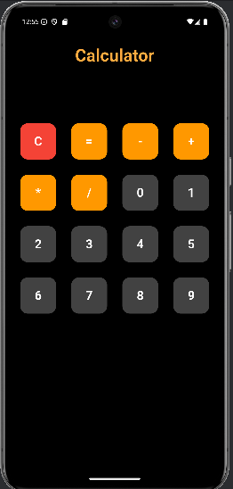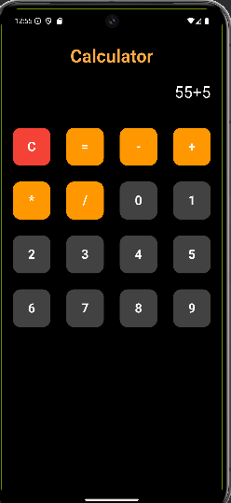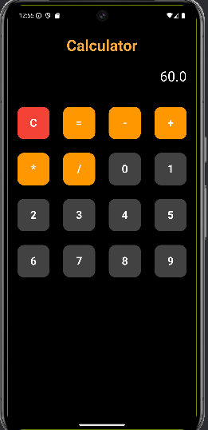

**6. Design a responsive UI for college website. The home page must have college name and logo. It must**

**have tabs like About Us, Academics, Library, Placements and Admissions. The home page must also**

**have an announcement section.**

**CODE:**

import 'package:flutter/material.dart';

void main() {

runApp(CollegeWebsiteApp());

}

class CollegeWebsiteApp extends StatelessWidget {

@override

Widget build(BuildContext context) {

return MaterialApp(

title: 'XYZ College',

debugShowCheckedModeBanner: false,

theme: ThemeData(

primarySwatch: Colors.*indigo*,

),

home: CollegeHomePage(),

);

}

}

class CollegeHomePage extends StatefulWidget {

@override

_CollegeHomePageState createState() => _CollegeHomePageState();

}

class _CollegeHomePageState extends State<CollegeHomePage> {

String selectedSection = 'Home';

final List<String> announcements = [

"Admissions for 2025 are open!",

"Library timings updated: 8 AM - 8 PM",

"Campus placements begin from May 10",

];

Widget _buildContent() {

switch (selectedSection) {

case 'About Us':

return Text(

'XYZ College was established in 1990 and has been providing quality education ever since.',

style: TextStyle(fontSize: 16));

case 'Academics':

return Text('Courses offered: B.Tech, M.Tech, BBA, MBA, and more.',

style: TextStyle(fontSize: 16));

case 'Library':

return Text(

'Our library houses over 50,000 books, digital resources, and study areas.',

style: TextStyle(fontSize: 16));

case 'Placements':

return Text(

'Top recruiters: Google, Amazon, Infosys, TCS. 95% placement rate.',

style: TextStyle(fontSize: 16));

case 'Admissions':

return Text(

'Apply now through our online portal. Last date: June 15, 2025.',

style: TextStyle(fontSize: 16));

case 'Home':

default:

return Column(

crossAxisAlignment: CrossAxisAlignment.start,

children: [

Text(

'Welcome to XYZ College!',

style: Theme.*of*(context).textTheme.headlineSmall,

),

SizedBox(height: 20),

Text('📢 Announcements',

style: Theme.*of*(context).textTheme.titleLarge),

SizedBox(height: 10),

...announcements.map((a) => Card(

margin: EdgeInsets.symmetric(vertical: 6),

child: ListTile(

leading: Icon(Icons.*campaign*),

title: Text(a),

),

)),

],

);

}

}

void _selectSection(String section) {

setState(() {

selectedSection = section;

Navigator.*pop*(context); // Close the drawer

});

}

@override

Widget build(BuildContext context) {

return Scaffold(

appBar: AppBar(

title: Row(

children: [

Icon(Icons.*school*),

SizedBox(width: 10),

Text('XYZ College'),

],

),

),

drawer: Drawer(

child: ListView(

padding: EdgeInsets.*zero*,

children: [

DrawerHeader(

decoration: BoxDecoration(color: Colors.*indigo*),

child: Column(

crossAxisAlignment: CrossAxisAlignment.start,

children: [

Icon(Icons.*school*, size: 48, color: Colors.*white*),

SizedBox(height: 10),

Text('XYZ College',

style: TextStyle(color: Colors.*white*, fontSize: 20)),

],

),

),

_buildDrawerItem('Home'),

_buildDrawerItem('About Us'),

_buildDrawerItem('Academics'),

_buildDrawerItem('Library'),

_buildDrawerItem('Placements'),

_buildDrawerItem('Admissions'),

],

),

),

body: SingleChildScrollView(

padding: EdgeInsets.all(16),

child: _buildContent(),

),

);

}

ListTile _buildDrawerItem(String title) {

return ListTile(

leading: Icon(Icons.*arrow_right*),

title: Text(title),

onTap: () => _selectSection(title),

);

}

}

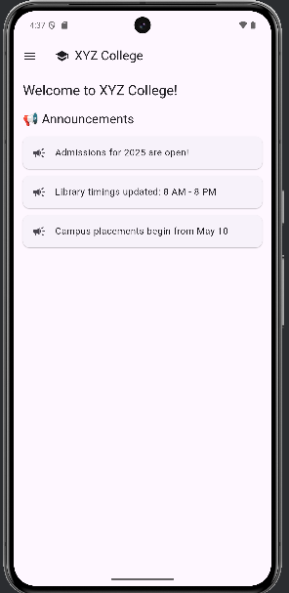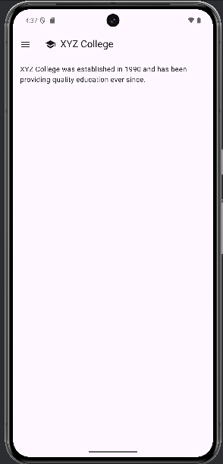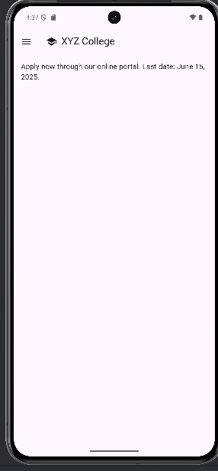

**8. Design a registration form and login form for clinical ERP system. Write 2 test cases for**

import 'package:flutter/material.dart';

void main() {

runApp(MyApp());

}

class MyApp extends StatelessWidget {

@override

Widget build(BuildContext context) {

return MaterialApp(

theme: ThemeData(

primarySwatch: Colors.*blue*,

),

home: LoginForm(),

);

}

}

class LoginForm extends StatefulWidget {

@override

_LoginFormState createState() => _LoginFormState();

}

class _LoginFormState extends State<LoginForm> {

final _formKey = GlobalKey<FormState>();

TextEditingController emailController = TextEditingController();

TextEditingController passwordController = TextEditingController();

// Simulating stored user credentials for the purpose of this demo

String? registeredEmail;

String? registeredPassword;

@override

void dispose() {

emailController.dispose();

passwordController.dispose();

super.dispose();

}

void checkLogin() {

if (emailController.text == registeredEmail && passwordController.text == registeredPassword) {

ScaffoldMessenger.*of*(context).showSnackBar(SnackBar(content: Text('Login Successful')));

Navigator.*push*(

context,

MaterialPageRoute(builder: (context) => ClinicalERPHomePage()),

);

} else {

ScaffoldMessenger.*of*(context).showSnackBar(SnackBar(content: Text('Invalid credentials')));

}

}

@override

Widget build(BuildContext context) {

return Scaffold(

appBar: AppBar(title: Text('Clinical ERP - Login')),

body: Padding(

padding: EdgeInsets.all(20),

child: Form(

key: _formKey,

child: ListView(

children: [

TextFormField(

controller: emailController,

decoration: InputDecoration(

labelText: 'Email Address',

labelStyle: TextStyle(color: Colors.*blueAccent*),

filled: true,

fillColor: Colors.*grey*[200],

border: OutlineInputBorder(borderRadius: BorderRadius.circular(10)),

),

keyboardType: TextInputType.*emailAddress*,

validator: (value) {

if (value == null || value.isEmpty) {

return 'Please enter your email';

}

return null;

},

),

SizedBox(height: 16),

TextFormField(

controller: passwordController,

decoration: InputDecoration(

labelText: 'Password',

labelStyle: TextStyle(color: Colors.*blueAccent*),

filled: true,

fillColor: Colors.*grey*[200],

border: OutlineInputBorder(borderRadius: BorderRadius.circular(10)),

),

obscureText: true,

validator: (value) {

if (value == null || value.isEmpty) {

return 'Please enter a password';

}

return null;

},

),

SizedBox(height: 24),

ElevatedButton(

onPressed: () {

if (_formKey.currentState?.validate() ?? false) {

checkLogin();

}

},

style: ElevatedButton.*styleFrom*(

padding: EdgeInsets.symmetric(vertical: 16, horizontal: 30),

backgroundColor: Colors.*blueAccent*, // Updated button style

shape: RoundedRectangleBorder(borderRadius: BorderRadius.circular(30)),

elevation: 5,

),

child: Text('Login', style: TextStyle(fontSize: 18)),

),

SizedBox(height: 16),

TextButton(

onPressed: () {

Navigator.*push*(

context,

MaterialPageRoute(builder: (context) => RegistrationForm(onRegister: (email, password) {

setState(() {

registeredEmail = email;

registeredPassword = password;

});

})),

);

},

child: Text("Don't have an account? Register here", style: TextStyle(color: Colors.*blueAccent*)),

),

],

),

),

),

);

}

}

class RegistrationForm extends StatefulWidget {

final Function(String, String) onRegister;

RegistrationForm({required this.onRegister});

@override

_RegistrationFormState createState() => _RegistrationFormState();

}

class _RegistrationFormState extends State<RegistrationForm> {

final _formKey = GlobalKey<FormState>();

TextEditingController fullNameController = TextEditingController();

TextEditingController emailController = TextEditingController();

TextEditingController passwordController = TextEditingController();

TextEditingController confirmPasswordController = TextEditingController();

@override

void dispose() {

fullNameController.dispose();

emailController.dispose();

passwordController.dispose();

confirmPasswordController.dispose();

super.dispose();

}

void registerUser() {

if (_formKey.currentState?.validate() ?? false) {

widget.onRegister(emailController.text, passwordController.text);

ScaffoldMessenger.*of*(context).showSnackBar(SnackBar(content: Text('Registration Successful')));

Navigator.*pop*(context);

}

}

@override

Widget build(BuildContext context) {

return Scaffold(

appBar: AppBar(title: Text('Clinical ERP - Registration')),

body: Padding(

padding: EdgeInsets.all(20),

child: Form(

key: _formKey,

child: ListView(

children: [

TextFormField(

controller: fullNameController,

decoration: InputDecoration(

labelText: 'Full Name',

labelStyle: TextStyle(color: Colors.*blueAccent*),

filled: true,

fillColor: Colors.*grey*[200],

border: OutlineInputBorder(borderRadius: BorderRadius.circular(10)),

),

validator: (value) {

if (value == null || value.isEmpty) {

return 'Please enter your full name';

}

return null;

},

),

SizedBox(height: 16),

TextFormField(

controller: emailController,

decoration: InputDecoration(

labelText: 'Email Address',

labelStyle: TextStyle(color: Colors.*blueAccent*),

filled: true,

fillColor: Colors.*grey*[200],

border: OutlineInputBorder(borderRadius: BorderRadius.circular(10)),

),

keyboardType: TextInputType.*emailAddress*,

validator: (value) {

if (value == null || value.isEmpty) {

return 'Please enter your email';

}

return null;

},

),

SizedBox(height: 16),

TextFormField(

controller: passwordController,

decoration: InputDecoration(

labelText: 'Password',

labelStyle: TextStyle(color: Colors.*blueAccent*),

filled: true,

fillColor: Colors.*grey*[200],

border: OutlineInputBorder(borderRadius: BorderRadius.circular(10)),

),

obscureText: true,

validator: (value) {

if (value == null || value.isEmpty) {

return 'Please enter a password';

}

return null;

},

),

SizedBox(height: 16),

TextFormField(

controller: confirmPasswordController,

decoration: InputDecoration(

labelText: 'Confirm Password',

labelStyle: TextStyle(color: Colors.*blueAccent*),

filled: true,

fillColor: Colors.*grey*[200],

border: OutlineInputBorder(borderRadius: BorderRadius.circular(10)),

),

obscureText: true,

validator: (value) {

if (value != passwordController.text) {

return 'Passwords do not match';

}

return null;

},

),

SizedBox(height: 24),

ElevatedButton(

onPressed: registerUser,

style: ElevatedButton.*styleFrom*(

padding: EdgeInsets.symmetric(vertical: 16, horizontal: 30),

backgroundColor: Colors.*blueAccent*, // Updated button style

shape: RoundedRectangleBorder(borderRadius: BorderRadius.circular(30)),

elevation: 5,

),

child: Text('Register', style: TextStyle(fontSize: 18)),

),

SizedBox(height: 16),

TextButton(

onPressed: () {

Navigator.*pop*(context); // Go back to the login screen

},

child: Text("Already have an account? Login here", style: TextStyle(color: Colors.*blueAccent*)),

),

],

),

),

),

);

}

}

class ClinicalERPHomePage extends StatelessWidget {

@override

Widget build(BuildContext context) {

return Scaffold(

appBar: AppBar(title: Text('Clinical ERP - Home')),

body: Center(

child: Text(

'Welcome to the Clinical ERP System',

style: TextStyle(fontSize: 24, fontWeight: FontWeight.*bold*),

),

),

);

}

}

